MSFS 2020 SkyVector Moving map

Installation:

Chrome Extension:

1. Download latest release from [Github](https://github.com/MoMadenU/msfs2020-skyvector/releases)
2. Extract the contents to a local folder
3. Open a new tab in Google Chrome and type chrome://extensions/
4. Enable developer mode by turning on the slider in the upper right hand corner
5. Click the Load Unpacked button located in the upper left hand corner
6. Choose the SkyVectorMovingMap folder that was extracted and click select folder.
7. You should now see it loaded:

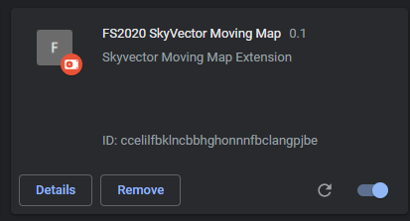

Web Service:

1. Navigate to the FSWebService\bin folder
2. Right click on FSWebService.exe and **choose “Run as administrator”**. If you get a dialog “Windows protected your PC” Click more info-> run anyway. Then click Yes to approve running it.
3. A small dialog box should appear. If you have not launched the sim yet, it will still attempt to connect

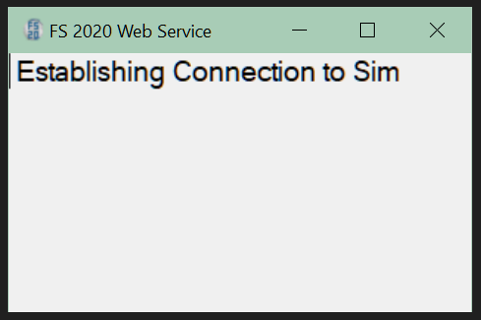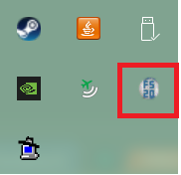

1. Launch the sim if its not running
2. Once connected to the sim, The server app will start the web service and minimize itself to the system tray.
3. You can always click on the tray icon to see the popup showing the status of the connection to the sim
4. Start up a flight either in the air or on the ground

Starting SkyVector

1. Open a new tab in Chrome and navigate to <https://skyvector.com>
2. Zoom out so you can see the general location of your aircraft. The airplane icon stays the same size so it should be easy to find
3. When zooming in, be sure to put your pointer on the airplane icon first before zooming. If you don’t it will zoom to another location and the icon will be out of view.

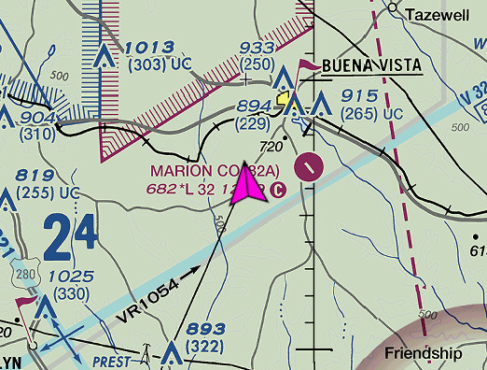

Go somewhere

1. If you are on the ground, right click on the airplane icon. If you are in flight right click,

in front of where the icon is currently heading

1. A popup will show Pick the last value in the list which is the GPS location
2. Right click where you want to go and again pick the last value
3. You now have a waypoint showing you the exact heading you will need to get there!

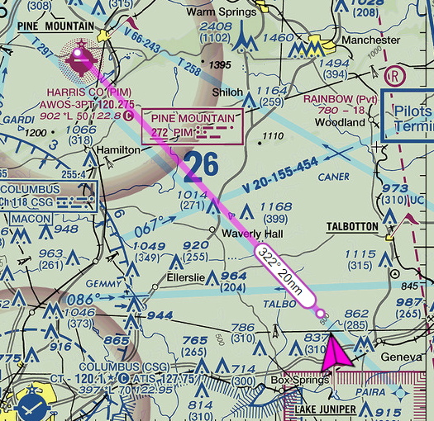

Changing the port

1. The default port is 8001. If you must change it, you have to do it both in the web service and the extension

For the extension

1. Click the extensions Icon in the upper right corner. The list of extensions will drop down. Pick FS2020 Skyvector Moving Map -> the three dots -> and then options

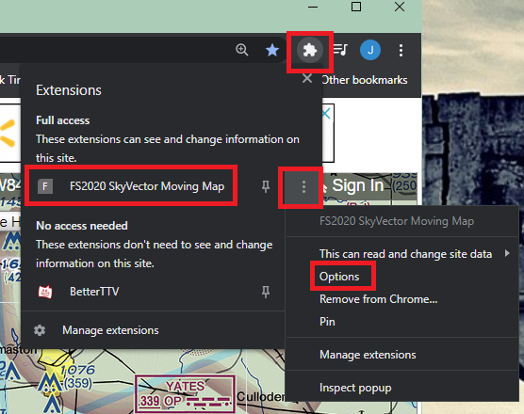

1. You will see a popup appear with the current port setting

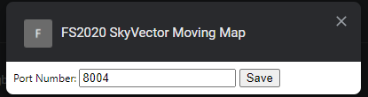

1. Change the value and click save. Then close the dialog.

For the web service:

1. Click on the apps icon in the tray to launch the popup.
2. Click the x to shut the app down
3. Go to the bin folder of the app and edit the file FSWebSevice.exe.config file
4. Change the port value to the same one you selected for the extension and then save the file
5. Right click on FSWebService.exe and **choose run as administrator** like before
6. If the sim is already running it will minimize itself to the system tray very quickly

Reload SkyVector: **Important**

1. Go back to the SkyVector tab, click on the map and press ctrl-F5 to fully reload it to pick up the changed port value